**BINARY TO DECIMAL CONVERSION**

**EXP NO: 26**

**AIM:** To write a C program to implement binary to decimal conversion.

**ALGORITHM:**

1)  Start

2)      Read the binary number from the user, say ‘n’

3)      Initialize the decimal number, d=0

4)      Initialize i=0

5)      Repeat while n != 0:

I .     Extract the last digit by: remainder = n % 10                                                             
ii.     n = n/10                                                           
iii.     d = d + (remainder * 2<sup>i</sup>)                                                           
iv.     Increment i by 1

6) Display the decimal number, d

7) Stop

**PROGRAM:**  
  
  
#include <stdio.h>  
  
void main() 

{   
  
 int num, binary_num, decimal_num = 0, base= 1, rem;   
  
  
    printf (" Enter a binary number with the combination of 0s and 1s \n");   
  
  
    scanf (" %d", &num);  
  
  
    binary_num = num;  
  
  
    while ( num > 0)   
  
  
    {   
  
  
        rem = num % 10;  
  
  
        decimal_num = decimal_num + rem *base;   
  
  
        num = num / 10;   
  
  
        base = base * 2;   
  
  
    }   
  
    printf ( " The binary number is %d \t", binary_num);  
  
  
    printf (" \n The decimal number is %d \t", decimal_num);     
  
  
}  
  
**INPUT:**

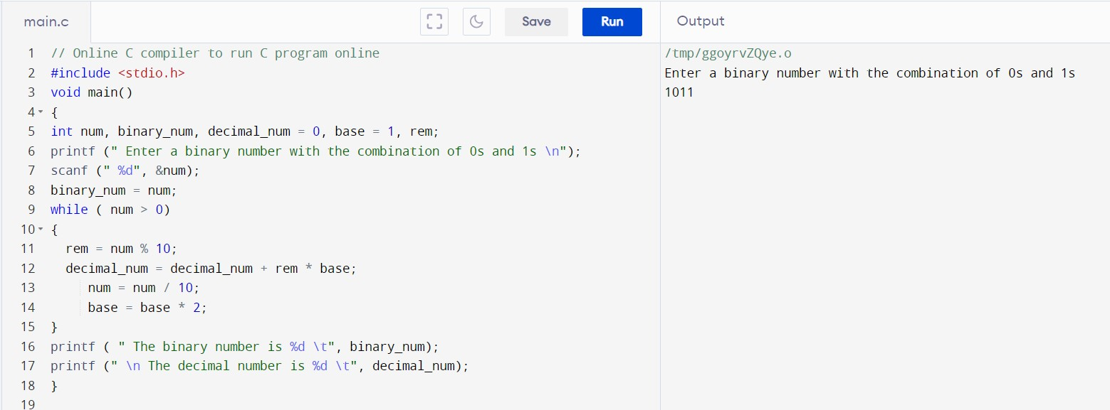

**OUTPUT:**

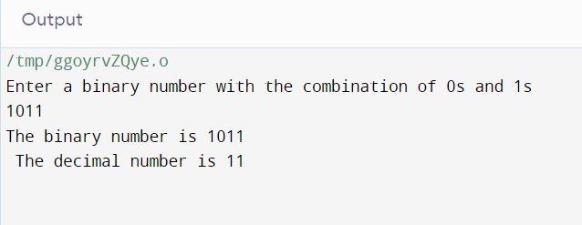  
   
  
  
**RESULT:**Thus the program was executed successfully using Dev C++.